## Optical Flow Algorithm:

Topic under consideration: **Face Mask Tracking**.

# **1. Introduction:**

As a part of optical flow algorithm study, I have created a video file where the person wearing mask in moving horizontally, vertically while wearing the mask and eventually takes off the mask. This is our input file under consideration. Experiment 3 is done on live webcam video. Lucas-Kanade Optical Flow algorithm is used in the first three experiment and Horn and Schunck Algorithm for Optical Flow is used in the last experiment. Results from all the three algorithms are given under each sub headings.

# **2.1 Experiment 1:**

**Initial Position:**

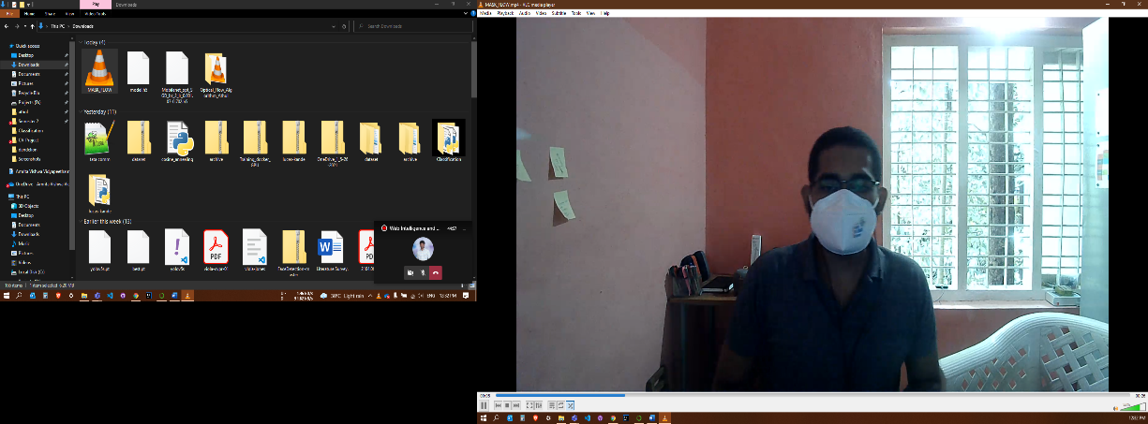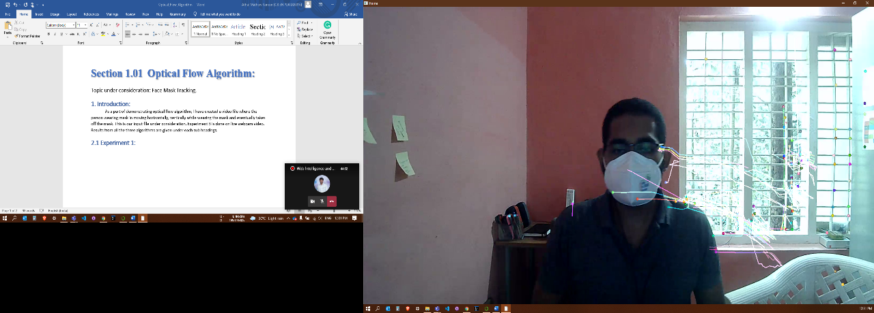

**Input Output**

**Moving Left:**

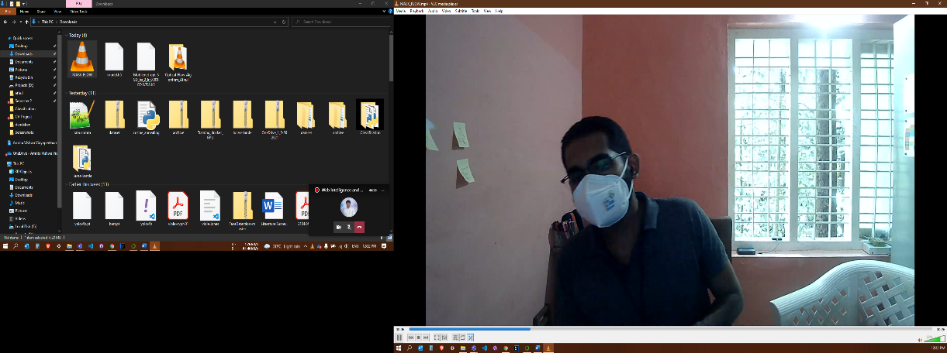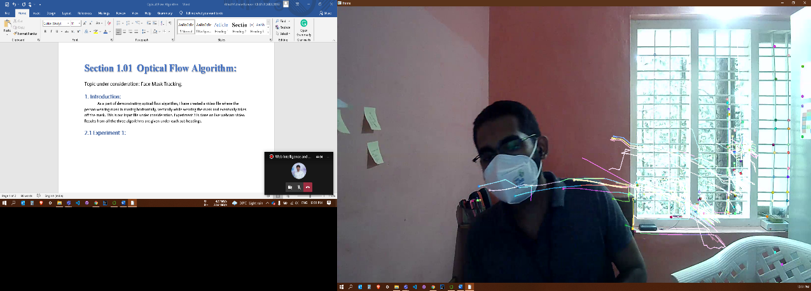

**Input Output**

**Moving Up:**

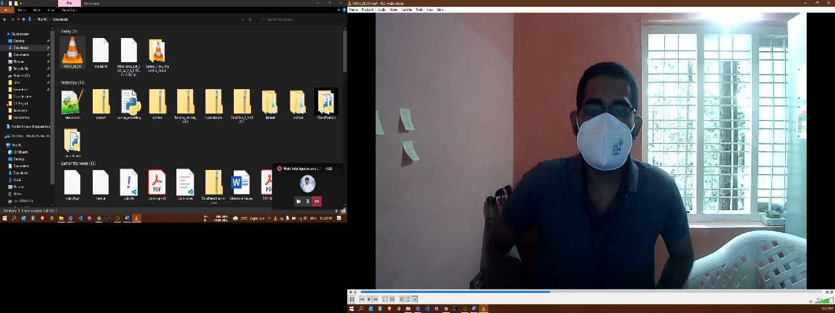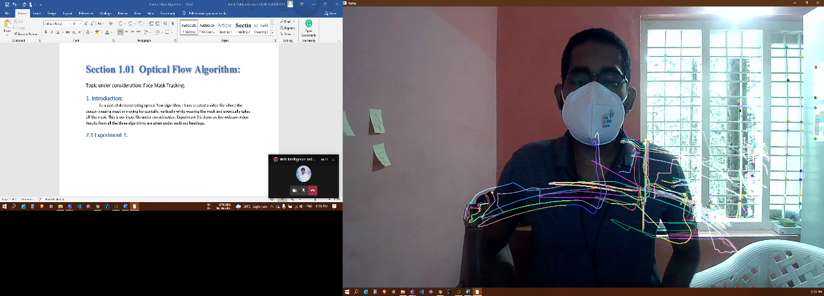

**Input Output**

**Taking Mask off:**

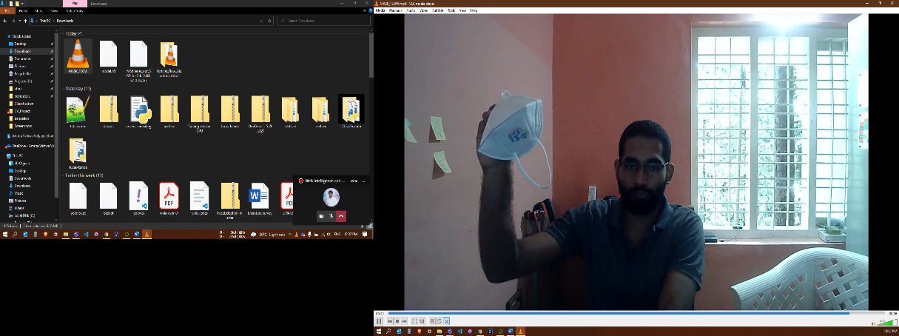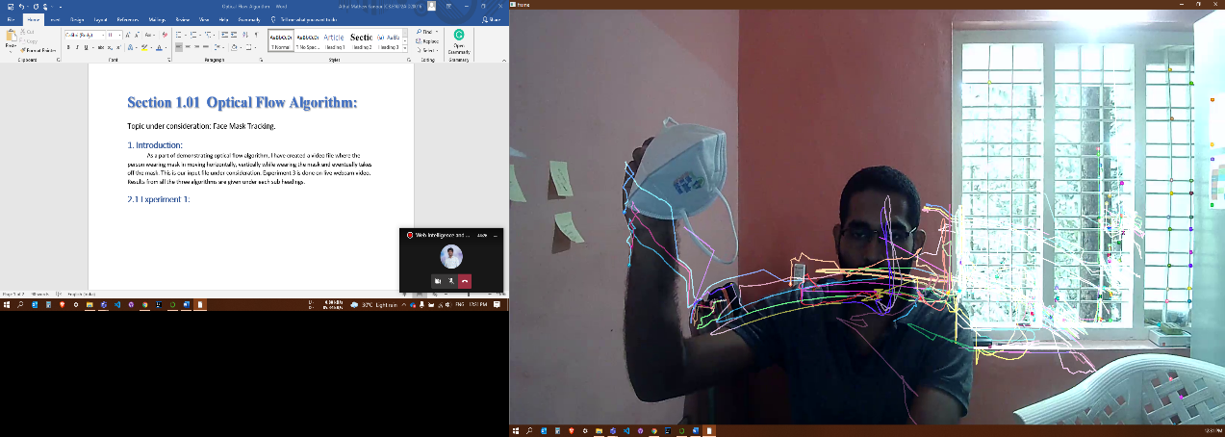

**Input Output**

# **2.2 Experiment 2:**

**Initial Position:**

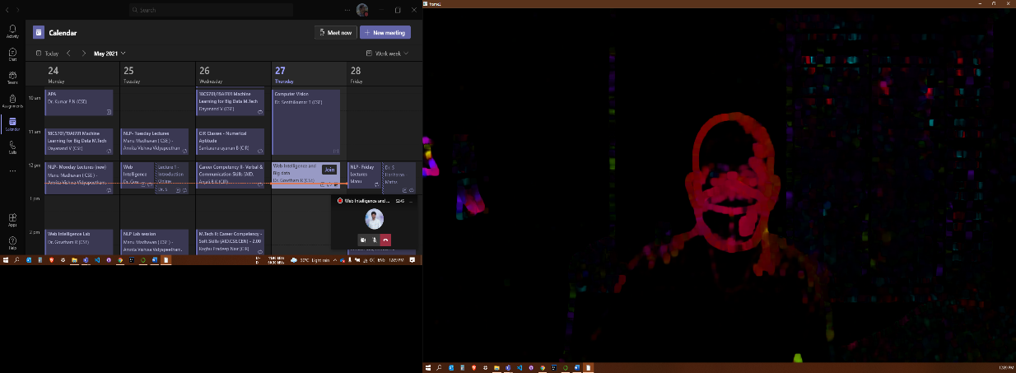

**Input Output**

**Moving Left:**

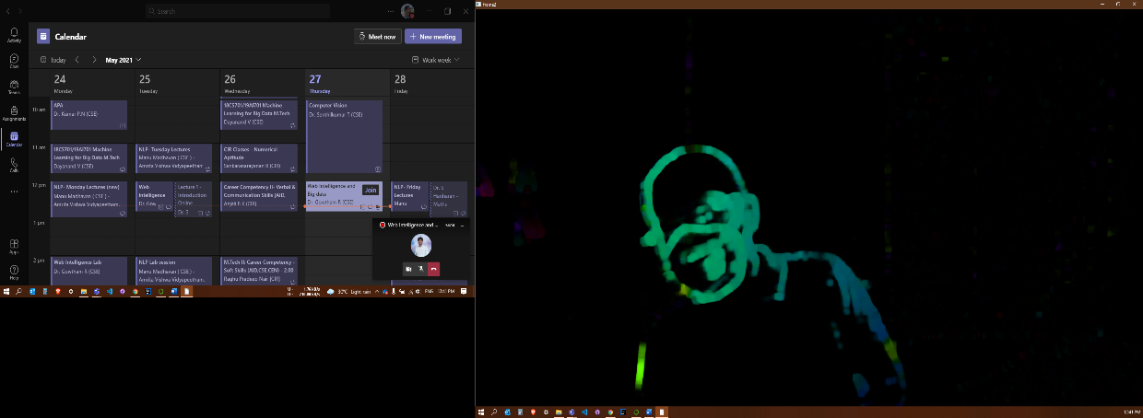

**Input Output**

**Moving Up:**

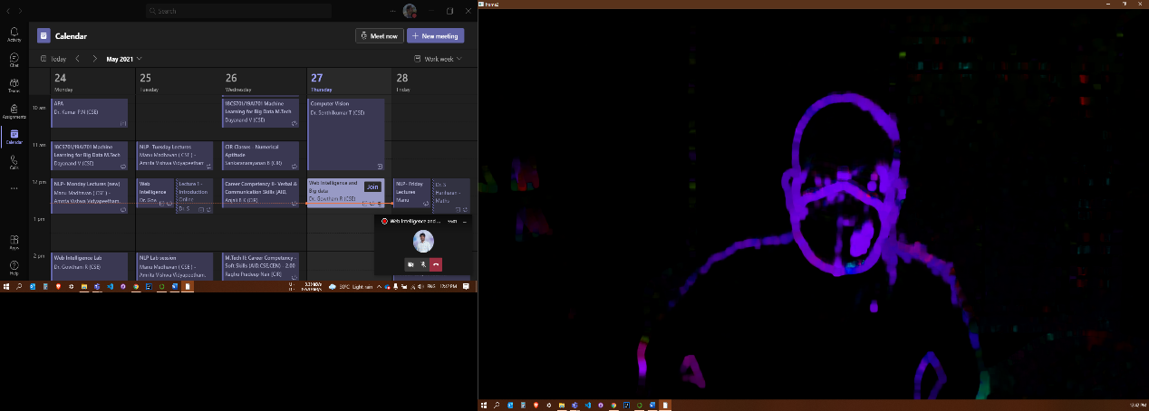

**Input Output**

**Taking Mask off:**

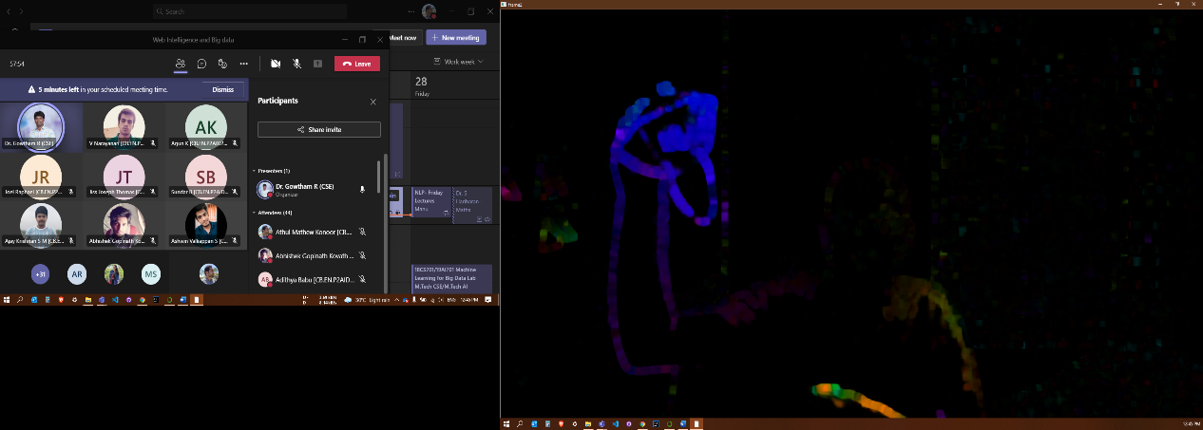

**Input Output**

**2.3 Experiment 3:**

Consecutive Sample Frames:

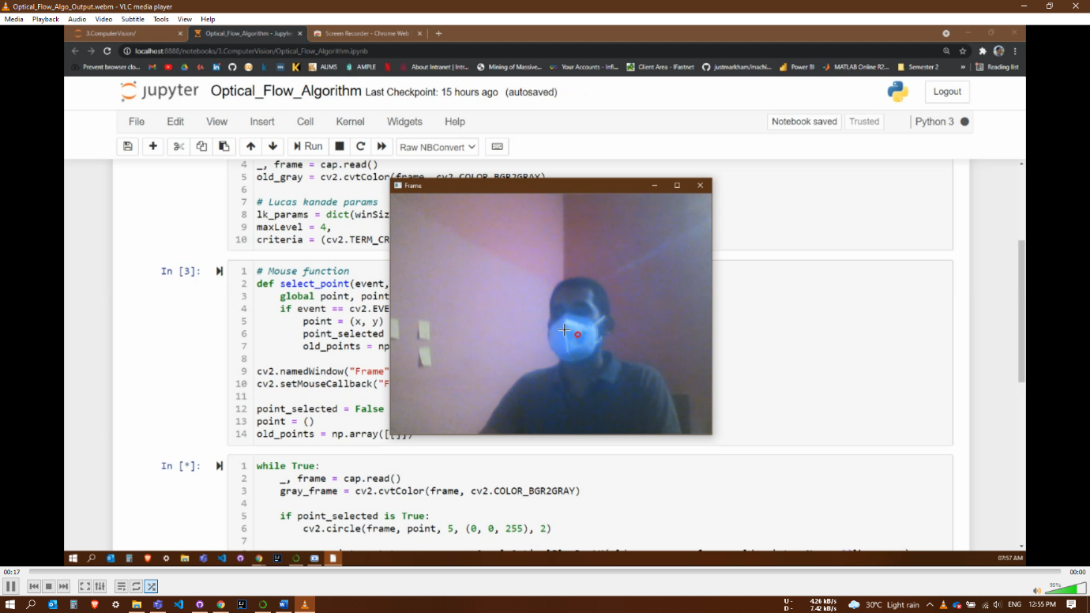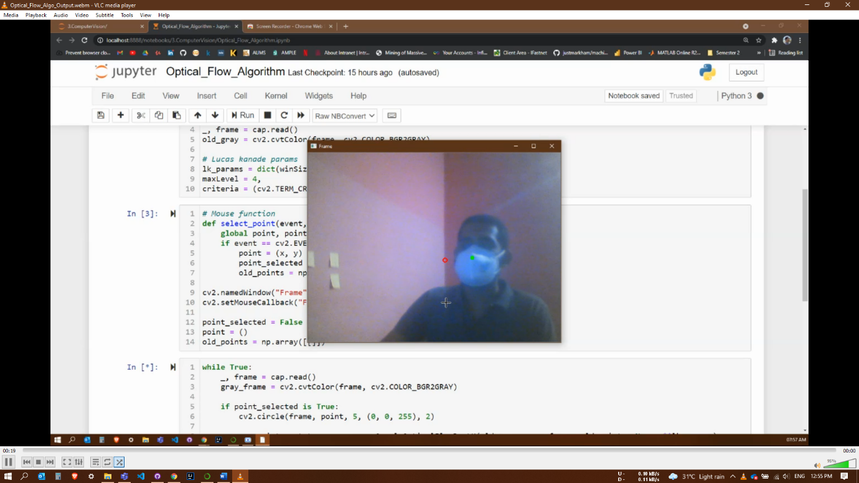

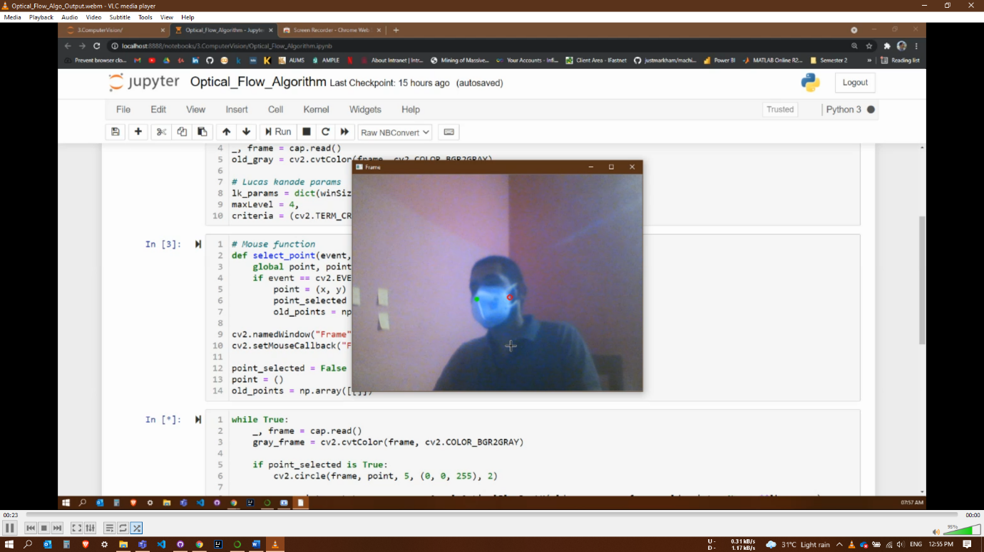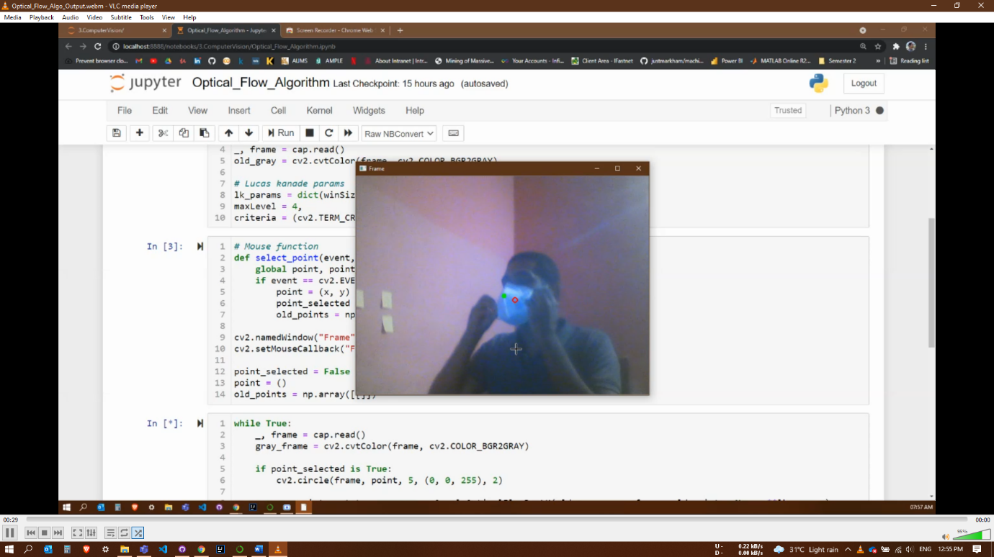

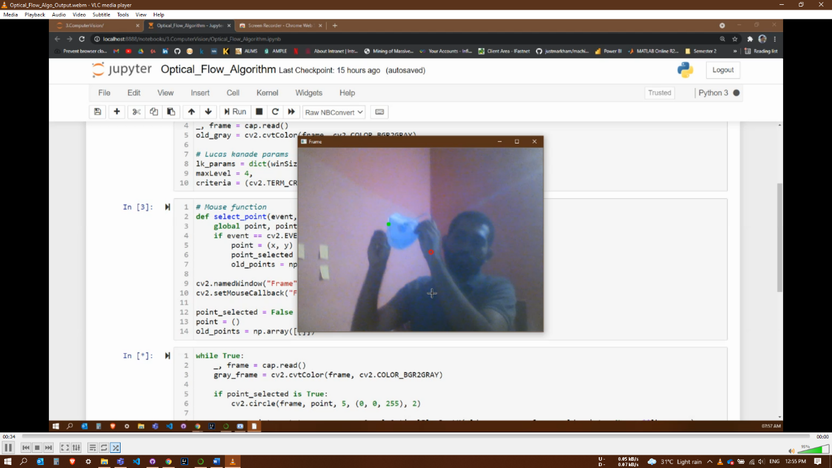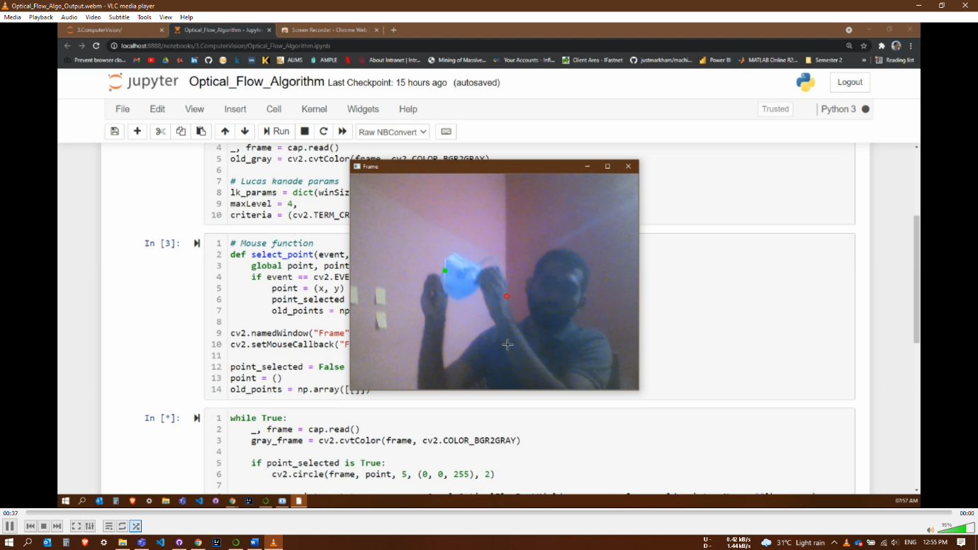

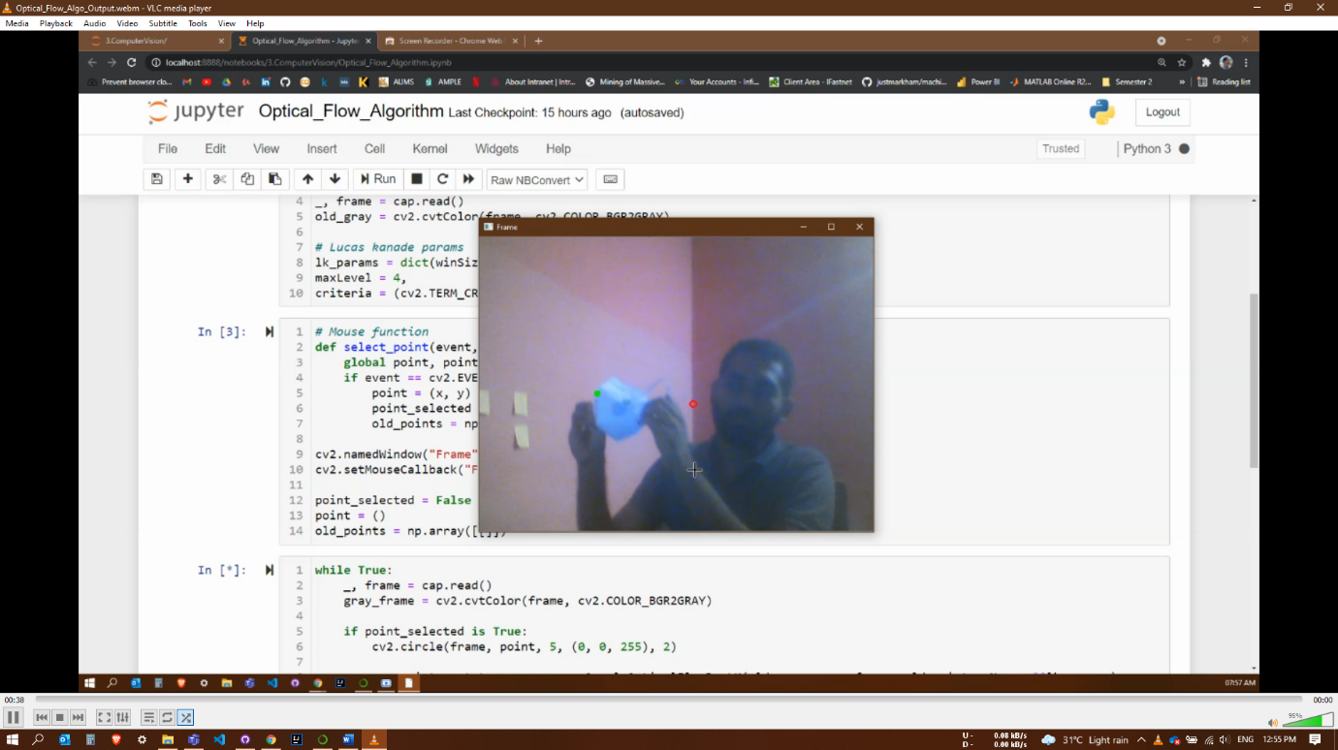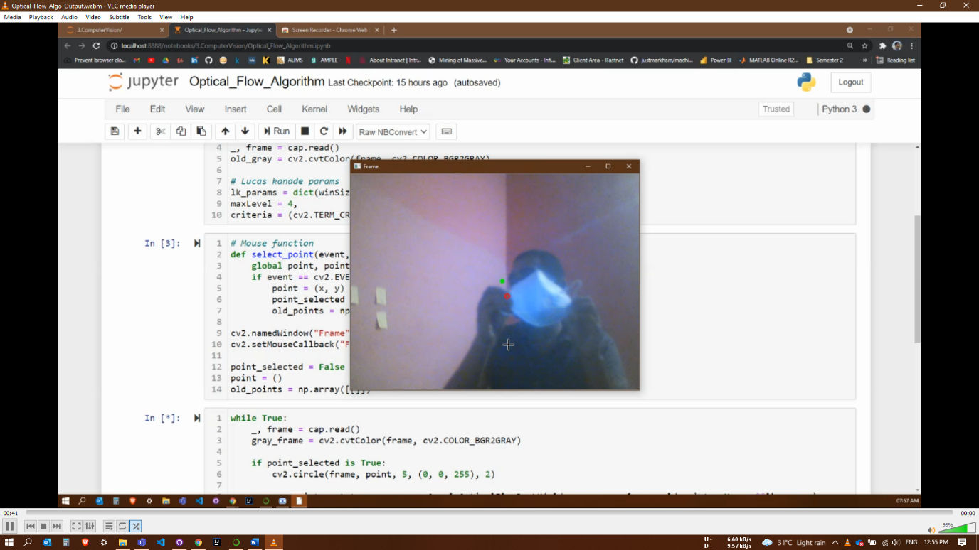

The above images show consecutive frames in the web cam feed where the white mask is being tracked (Green-dot) while the person moves left and taking the mask off.

Note: Orange arrow is used for better visibility of the green-dot.

# **2.4 Experiment 4 (Horn and Schunck Algorithm):**

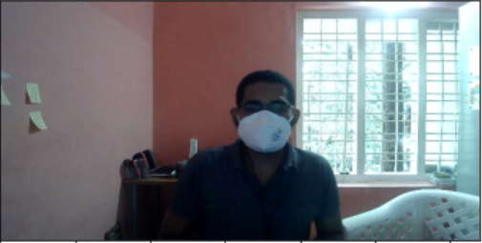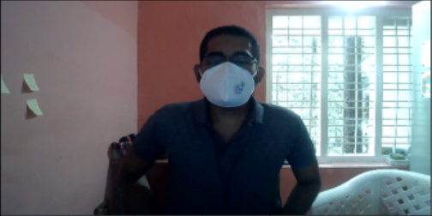

**Input Frame 1 Input Frame 2**

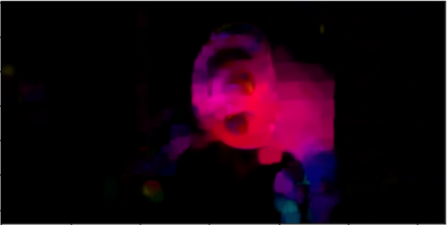

**Output**

# **3. Performance Metrics:**

|  |  |  |
| --- | --- | --- |
| **Sl No** | **Metric** | **Comment** |
| 1 | Angular Error (AE) | The AE between a flow vector (u,v) and the ground-truth flow (uGT,vGT) is the angle in 3D space between (u,v, 1.0) and (uGT,vGT, 1.0). The AE can be computed by taking the dot product of the vectors, dividing by the product of the vectors, dividing by the product of their lengths, and then taking inverse cosine. The goal of the AE is to provide a relative measure of performance that avoids the “divide by zero” problem for zero flows. Errors in large flows are penalized less in AE than errors in small flows. |
| 2 | Absolute Error in flow endpoints (EE) | EE = (u − uGT)2 + (v − vGT)2. |
| 3 | Interpolation Error (IE) | Interpolation error (IE) to be the root-mean-square (RMS) difference between the ground-truth image and the estimated interpolated image. |

# **4. References:**

* Lucas-Kanade Optical Flow in OpenCV : <https://docs.opencv.org/3.4/d4/dee/tutorial_optical_flow.html>

# Optical Flow with Lucas-Kanade method : <https://pysource.com/2018/05/14/optical-flow-with-lucas-kanade-method-opencv-3-4-with-python-3-tutorial-31/>

* Horn and Schunck Algorithm : <http://datahacker.rs/013-optical-flow-using-horn-and-schunck-method/>
* Performance Metrics: <https://vision.middlebury.edu/flow/floweval-ijcv2011.pdf>

***All the code and input video used in the study is available in my GitHub Repo:*** <https://github.com/toshihiroryuu/Optical_Flow_Algorithm>

***Output of Experiment 3 is available in the Google drive link:*** <https://drive.google.com/file/d/1hVl7E4Sz2F_16Lt4oPuVHT5add_FupCP/view?usp=sharing>